We are thankful you chose
Twin Lakes Manor
and wish you & yours a wonderful Holiday!

Office Staff Change your clocks back one hour at
Jessica Beck - Property Manager 2 am on Sunday and change your Stefanie Feldmann- Leasing Agent smoke detector batteries too!!!
Nikki Fulton- Administrative Assistant
Angela Rodriquez- Bookkeeper
Veteran’s Day
Office Closed
Office Closed
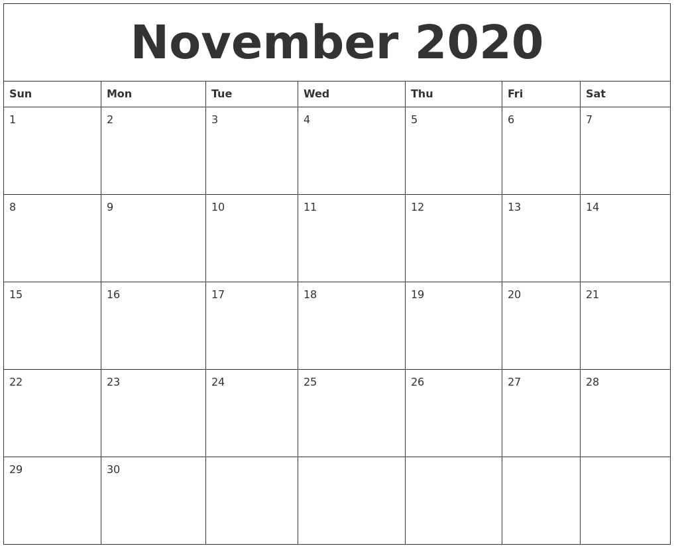
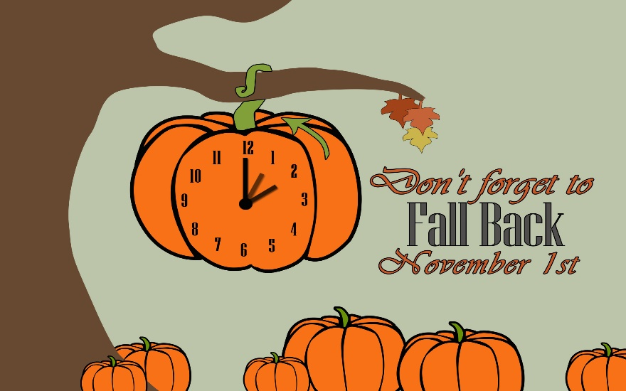
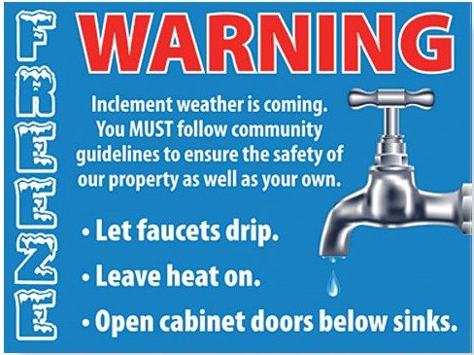
**Make sure to look at the back of newsletter for important snow removal info! **
Clocks back on hour!
Rent is LATE

RENT DUE
RENT
DUE

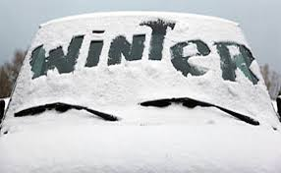

Preparedness Reminders

Snow Removal
You will need a Snow Shovel and Windshield Ice Scraper/Brush
because we do not go between cars or clear them off.

We ask your cooperation in expediting parking lot snow removal…
In the event of any snowfall over 3 inches,
WATCH for the SNOWPLOW, please be ready to move your vehicle(s)
to an area that has been cleared.

Please DO NOT park with bumpers / tow hooks extended over curbs & sidewalks…
It is dangerous for pedestrians and impedes snow removal.

Thank you!
Twin Lakes Manor Maintenance Team

