**Get PAID FOR PAYING your rent EARLY!**

Pay rent early and be entered to win $50 off next months’ rent. Turn this slip in with your rent OR email Lindsey after you have paid online and be entered to win. All you must do is pay before the 1st!



Questions or entry? Please e-mail Lindsey at [fallsasst@nolanred.com](mailto:fallsasst@nolanred.com).

Thank you early birds!

NO SMOKING

To make our community more comfortable for everyone, we became a smoke-free community last year! As a reminder, NO SMOKING is allowed anywhere on the property. This will be enforced with lease violations, fines and possibly further lease action if needed. Please be kind to your neighbors and do not smoke at The Falls.

SK SECURITY

Our Security Team can be reached by calling 913-444-9296. Please contact for noise disturbances or minor security issues. If you are having any issues that need to be addressed by the Mission Police Department, please call their non-emergency number at 913-676-8300 or call 911 in case of emergency.



Fall is HERE! Stay cool and renew at The Falls. Renew Early for best rates! Rent, Renew or REFER to win some awesome prizes this month!

(ask us for details!)

(Reminder- you must fill out a 60 day notice to vacate if you do not renew)



PACKAGE SEASON IS AMONG US!

Please help us to help you get your packages as smoothly as possible.

-Please come to office to check on packages instead of calling

-Please pick up packages during the week **on the day they are delivered**! If you need to pick up on the weekend, please remember only one person is here so you may have to wait or come back.

-Please check your mailbox for packages or key to larger parcel box before asking to check in package closet

-Please let us know if you are sending anyone else to pick up your package

THANK YOU! Falls Office Staff

**NOV 2020**

The Falls Newsletter

**Danielle**

**Property Manager**

**Lindsey**

**Assistant Manager**

**Tim**

**Maintenance Supervisor**

**Sales Team:**

**Jennifer, Oscar & Brooke**

**Maintenance Team:**

**Lance, Bob,**

**Thomas, Andy**

**Office Hours:**

**Monday-Friday**

**9am to 6pm**

**Saturday**

**10am to 5pm**

**Sunday**

**1pm to 5pm**

Wine-Down Wednesdays!

Sep 4th, 11th, 18th, & 25th

Come by the office from 4-6 and relax with a glass of wine.

It is the middle of the week and we all need to relax before the weekend.

26th

151, 152, 153, 154, 155,

156, 157, 158, 159, 160

251, 252, 253, 254, 255,

256, 257, 258, 259, 260

351, 352, 353, 354, 355,

356, 357, 358, 359, 360

24th

1115, 1116, 1117, 1118,

1119, 1120, 1122, 1124

2115, 2116, 2117, 2118, 2119, 2120, 2122, 2124

3115, 3116, 3117, 3118, 3119, 3120, 3122, 3124

19th

122, 143, 144, 145,146,

147, 148, 149, 150

222, 243, 244, 245,246,

247, 248, 249, 250

322, 343, 344, 345,346,

347, 348, 349, 350

17th

1108, 1109, 1110, 1111, 1112, 1113, 1114

2108, 2109, 2110, 2111, 2112, 2113, 2114

3108, 3109, 3110, 3111, 3112, 3113, 3114

12th

124, 125, 126, 127,128,

129, 130, 131,132, 133,

134, 135

224, 225, 226, 227,228,

 229, 230, 231,232, 233,

234, 235

324, 325, 326, 327,328,

329, 330, 331,332, 333,

334, 335

10th

1045, 1046, 1047, 1048,

1049, 1050, 1051, 1052,

1053, 1054, 1055

2045, 2046, 2047, 2048,

2049, 2050, 2051, 2052,

2053, 2054, 2055

3045, 3046, 3047, 3048,

3049, 3050, 3051, 3052,

3053, 3054, 3055

5th

120, 121, 123, 136,

137, 138, 139, 140,

141, 142

220, 221, 223, 236,

237, 238, 239, 240,

241, 242

320, 321, 323, 336,

337, 338, 339, 340,

341, 342

1100, 1101, 1102, 1103,

1104,1105, 1106, 1107

2100, 2101, 2102, 2103,

2104, 2105, 2106, 2107

3100, 3101, 3102, 3103,

3104, 3105, 3106, 3107

3rd

FALLS OFFICE CLOSED



* . 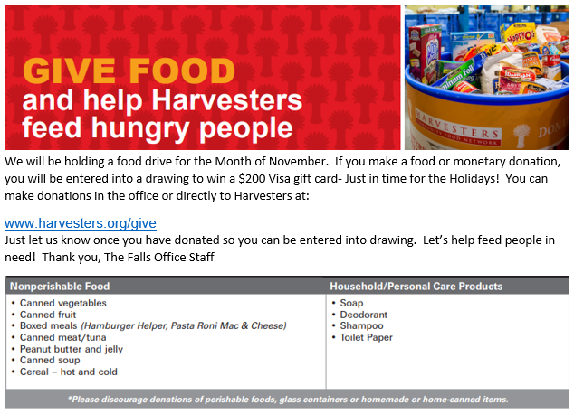

**For Best Pest Control Results**

1. Practice Good Housekeeping.

2. Remove all cardboard boxes from the apartment.

3. Open all cabinets and remove all items inside prior to treatment for best results.

4. Don’t leave any food out in your apartment.

5. Pest control is not an optional service.

6. Please be prepared on your scheduled day, and let the office know immediately if you must reschedule.

PEST CONTROL